**Self Check**

**根据短文内容，从方框中选择恰当的单词填空，注意形式变化。**

|  |
| --- |
| hobby, future, holiday, space, even, become, believe, sky, join, plant |

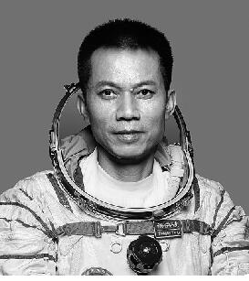

Do you know about Tang Hongbo? On June 17, 2021, he went into (1)_______ with two other Chinese astronauts Nie Haisheng and Liu Boming.

Tang Hongbo was born (出生) in a village in Hunan Province in October 1975. At school, he was hard-working and one of his (2)_______ was reading. Whenever he was free, he would read different kinds of books. After school, he helped his parents (3)_______ rice or feed the cow. During his summer (4)_______, he also helped his parents do farm work. Sometimes he (5)_______ helped them do some heavy work.

At an early age, Tang Hongbo would be very happy when he saw planes flying in the (6)_______. “I want to be a pilot in the (7)_______,” he said to his parents one day. They supported (支持) their son in his dream, although they were worried about their son's safety (安全). In 1995, Tang Hongbo (8)_______ the army and his dream of (9)_______ a pilot came true. He trained very hard because he (10)_______ that hard work could make him become an excellent pilot. Because of his excellent performance (表现), he became an astronaut in May 2010.

**答案**

**Self Check**

1. space  2. hobbies  3. plant  4. holidays  5. even

6. sky  7. future  8. joined  9. becoming   10. believed